Fig 1. Identification of unknown plasmid using Restriction Enzyme Digestion and Gel Electrophoresis
A : 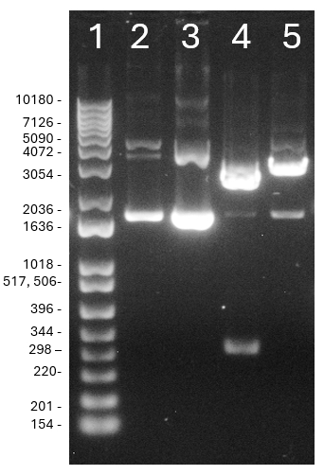

B:
Expected Digestion bands in gel if unknown plasmid is pGFP-S12
2 - control | 3 - BamHI | 4 – Pvul1 | 5 - Ndel
1-4 bands | 2 cuts at bp 70, 614  = 2 bands of roughly 600bp and 2400bp | No digest- looks the same as control | 2 cuts at bp 324, 1088  = 2 bands of roughly 700bp and 2300bp
Expected Digestion bands in gel if unknown plasmid is pGEM-T
2 – control | 3 - BamHI | 4 – Pvul1 | 5 - Ndel
1-4 bands | No digest- looks the same as control | 2 cuts at bp 326, 2890  = 2 bands at roughly 2500bp, 500 bp | 1 cut at bp 82  = 1 band at 3000bp

C: Table of Figure 1A Lane 1, Identification of bands of DNA Ladder on gel
Ladder band | Distance travelled - center, cm | Invitrogen 1 Kb-Plus DNA ladder length (bp) | Log of DNA size
1 | 2.4 | 10180 | 4.007747778
2 | 2.6 | 9162 | 3.961990287
3 | 2.75 | 8144 | 3.910837765
4 | 2.9 | 7126 | 3.852845818
5 | 3.05 | 6108 | 3.785899028
6 | 3.3 | 5090 | 3.706717782
7 | 3.6 | 4072 | 3.609807769
8 | 4.1 | 3054 | 3.484869033
9 | 4.9 | 2036 | 3.308777774
10 | 5.65 | 1636 | 3.213783299
11 | 6.65 | 1018 | 3.007747778
12 | 7.15 | 511 | 2.7084209
13 | 7.8 | 396 | 2.597695186
14 | 8.45 | 344 | 2.536558443
15 | 8.95 | 298 | 2.474216264
16 | 9.5 | 220 | 2.342422681
17 | 10.15 | 201 | 2.303196057
18 | 10.8 | 154 | 2.187520721
D: Standard Curve of Distance Travelled vs log DNA size
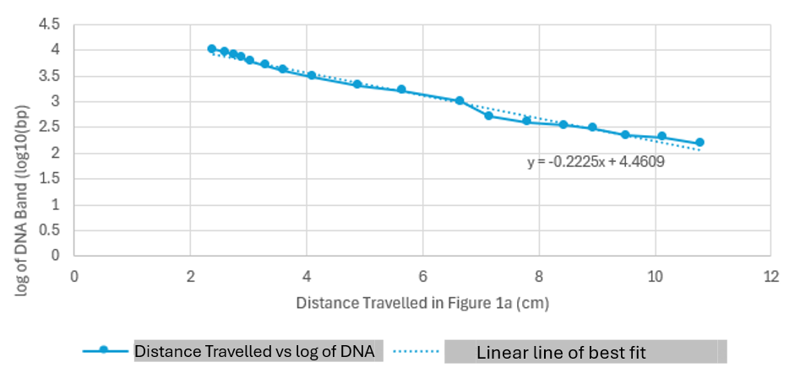
Linear line of best fit s
Distance Travelled vs log of DNAs
E: Table of distance travelled & computed DNA fragment length of Lanes 2-5 in Figure 1A
Lane | Band | Distance travelled - center, cm | log of DNA Band log(bp) | DNA band length (bp) | DNA Band (kb), 1 decimal
2 – control | i | 3.35 | 3.715525 | 5194.275733 | 5.2
2 – control | ii | 3.65 | 3.648775 | 4454.254219 | 4.5
2 – control | iii | 5.3 | 3.28165 | 1912.713838 | 1.9
3 – BamHI | i | 3.75 | 3.626525 | 4231.798692 | 4.2
3 – BamHI | ii | 5.4 | 3.2594 | 1817.188585 | 1.8
4 – PvulI | i | 4.3 | 3.50415 | 3192.640364 | 3.2
4 – PvulI | ii | 5.25 | 3.292775 | 1962.343359 | 2
4 – PvulI | iii | 8.7 | 2.52515 | 335.0811521 | 0.3
5 - Ndel | i | 3.4 | 3.7044 | 5062.907583 | 5.1
5 – Ndel | ii | 4.05 | 3.559775 | 3628.899994 | 3.6
5 - Ndel | iii | 5.25 | 3.292775 | 1962.343359 | 2

F: Plasmid Ma
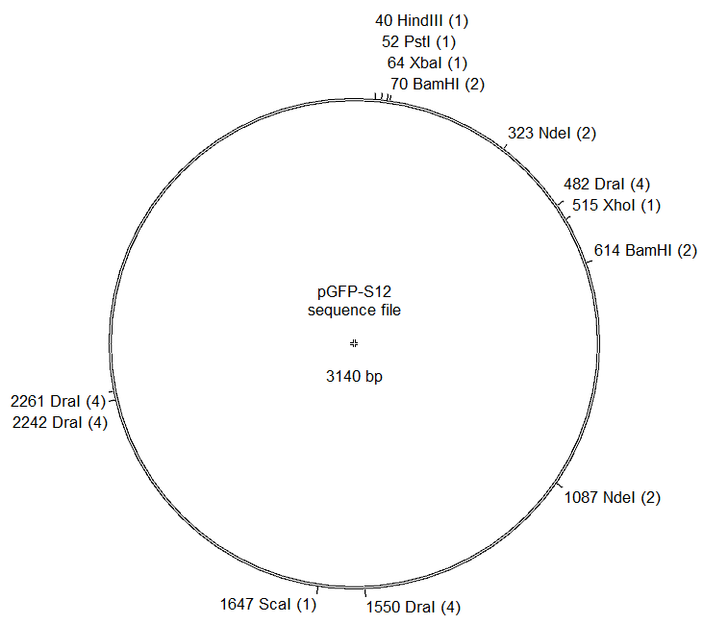
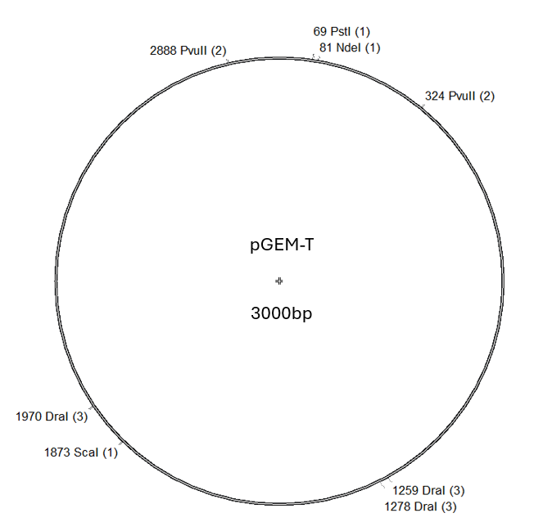

Figure 1: A) Gel image from gel electrophoresis of digested/undigested unknown plasmid. Lane 1 is the Invitrogen 1 Kb-Plus DNA Ladder. Lane 2 is the positive control consisting of the undigested, circular unknown plasmid. Lane 3, 4, and 5 contain the unknown plasmid incubated with the restriction enzymes BamHI, PvulI and Ndel respectively.
B) Table of expected digestion fragments for the two possible plasmid identities.
C) Table of the DNA Ladder band in Figure 1A Lane 1. Distances were hand measured rulers and ladder bands were identified starting with the indicator bands(1636 and 2036 bp) according to Invitrogen Manual. The log of the DNA band length was calculated.
D) Using the table from Figure 1C, a standard curve between distance travelled and the log of the DNA band was created in Excel. A linear line of best fit was also applied to the graph.
E) Table of the measured bands in Figure 1A Lanes 2-5. DNA lengths calculated using standard curve and line of best fit created in Figure 1D.
F) Plasmid maps of expected digestion sites on pGFP-S12 and pGEM-T for all available restriction endonucleases in BIOL 341 course. (Enzymes recordedBamHI, DraI, HindIII, NdeI, PstI, PvuII(HF), ScaI(HF), XbaI, XhoI)

We wanted to confirm the identity of an unknown plasmid to either be pGEM-T or pGFP-S12. Technique of using restriction endonucleases (RE) was chosen to help identification. Because REs cut at 6nt specific sites within the plasmid, one type of RE will digest different sites for pGEM-T and pGFP-S12 plasmids respectively, thus creating different expected digested fragments. To visualize the sizes of these digested(or undigested!) fragments, we used gel electrophoresis (1% Agarose gel) to separate the DNA fragments via electrical current. The travelling speed of the fragment is limited by factors such as DNA size and whether there is external coiling on the DNA.
Using the data presented in Figure 1, we concluded that the identity of the unknown plasmid is pGEM-T. Depending on the plasmid, we have lanes where we expect no cuts, and thus need a control to compare against a circular, possibly coiled plasmid that appears in multiple different formations. Lane 3 and 5 (Figure 1A) both have their major bands at the same distances to the control lane. There does not seem to be evidence of digestion further downstream as expected of pGEM-T but contrasting pGFP-S12. Lane 4 (Figure 1A) shows a plasmid has clearly been digested. A band appears at ~2000bp, and a cut around the ~300bp mark. For pGFP-S12, we did not expect any digestion, but due to the clear presence around the 300bp, we can confirm it has indeed been digested. Although for the fragments of the pGEM-T digest, we expected values closer to ~2500bp and ~500bp, the gel seems to clearly show digested sequences closer in the <1600bp range, which rules out pGFP-S12.

